## Introduction AWS Networking-Connectivity

AWS has many network connectivity options.

## AWS Virtual Private Cloud

AWS Virtual Private Cloud is also called AWS VPC.

VPC is a service that lets you isolate your AWS resources in an isolated network.

The boundaries created around the resources let AWS restrict the network traffic.

In addition, it allows you to include the sections of the AWS Cloud that you want in the isolated network.

Resources can be organized in subnets.

A subnet is a section in the VPC that can contain specific resources.

## Internet Gateway

Public traffic can be allowed to your VPC.

The traffic is allowed by an Internet Gateway.

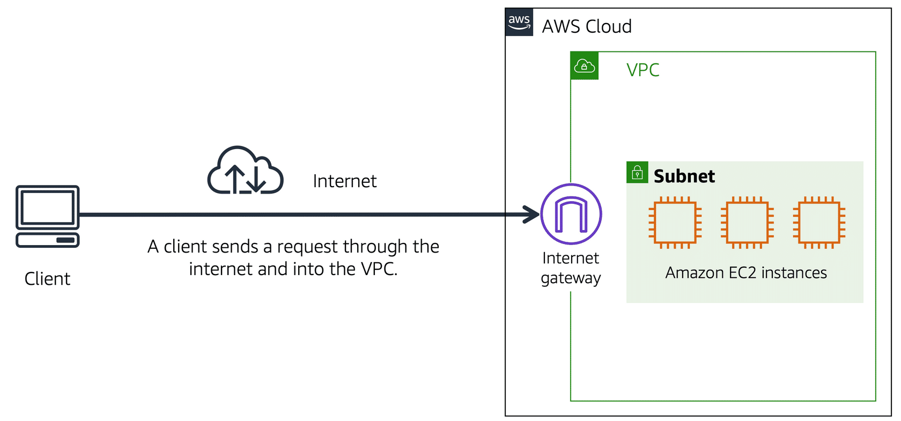

An Internet Gateway is a door between the VPC and the internet.

The traffic enters the VPC through the Internet Gateway.

Without the Internet Gateway, you cannot access the resources in the VPC.

## Virtual Private Gateway

A Virtual Private Gateway is used to access private resources in the VPC.

It has extra layers of protection.

The Virtual Private Gateway encrypts the internet traffic, keeping it protected.

It is a component that allows the encrypted traffic to enter the VPC.

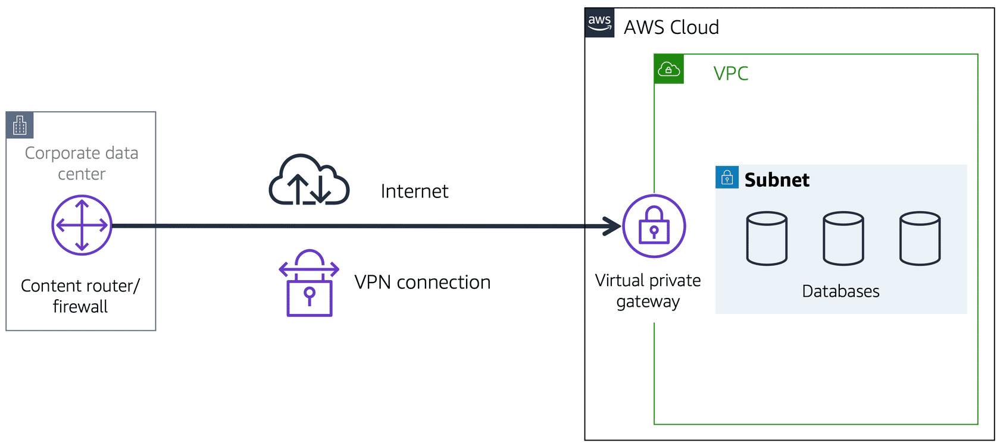

The Virtual Private Gateway allows you to make a Virtual Private Network (VPN) between the VPC and private network.

It only allows traffic from approved networks.

Many businesses use VPNs to ensure that their traffic and data are secure.

AWS Direct Connect

AWS Direct Connect lets you make a dedicated private connection between the Data Center and a VPC.

A dedicated connection is to have the link for yourself.

The link is not shared with others.

Only you and your data can travel through the connection.

